Exercise 7 – Basic SQL Queries

The exercises in this lab will be based on the following ERD from exercise 5.

Remove all tables from your database schema and run the script **book_shop_data.sql** to create the tables below and to insert same data. You may use the **book_shop_drop.sql** script file to remove the tables when you are done. Check that each of the tables contains data.

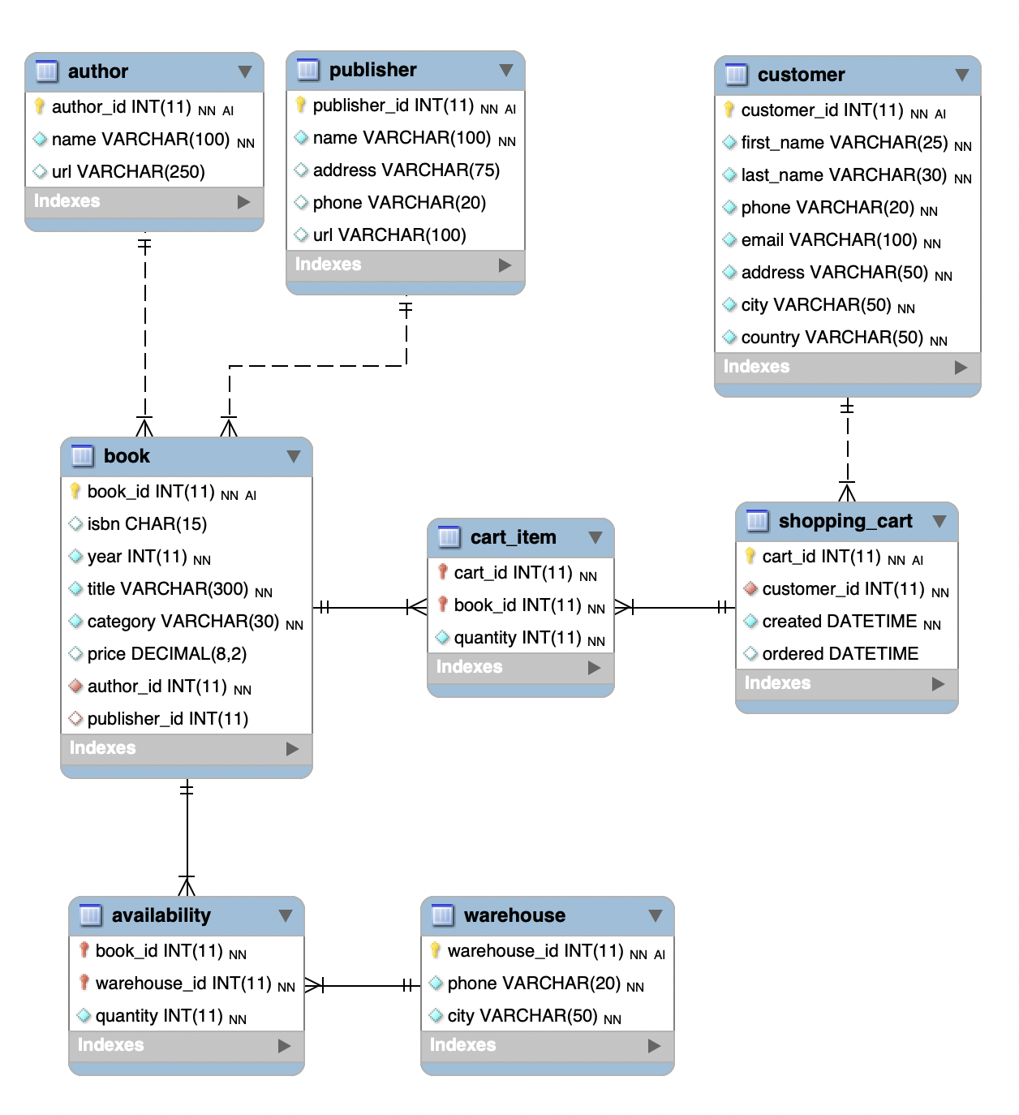

# Part A – With Instructor

## Note

Some of the questions may require more than one SQL statement to complete.

## Question 1

Show the names of all the **authors** in the database. Limit the result set to only 10 rows. This 2nd part of the question was not shown in class. You may search online to find how to limit the results.

## Question 2

Get the total number of books with book_id 7091 that are currently available in all warehouses. Get a screenshot of this query.

Update warehouse 2 to have 10 more copies (if there was 23 now it should be 33) and update warehouse 1 to have 50 copies. Get a screenshot showing both queries.

Run the initial query again to show the updates.

## Question 3

Show all the books whose price is between 10 and 12 in the category of dogs but do not include any books with the year of 0. Order the output so that the newest books appear at the top.

## Question 4

Get all the publishers whose phone number suggests that they are in the UK (the phone number will start with +44). Order the output so that the listing is alphabetical (A-Z).

## Question 5

We want to know the titles and categories of the books that were placed into cart 214. Although you could use a join or subquery for this, you must use the queries described here to receive credit.

Write a query that finds the book ids for the items in cart 214.

Write a query that uses the “in” clause to get the titles of the books from the ids found in the previous query.

## Question 6

The book “Shadowmancer” needs to be removed from the system. This means that it needs to be removed from all shopping carts, from all warehouses and of course from the book table. Write the queries necessary to complete this.

## Question 7

A new business rule was received where the number of pages of each book must be added to the database.

Write the command necessary to modify the database structure to include the number of pages for the books. Because we don’t have the actual number of pages of each book, we will estimate them by multiplying the price by of each book by 18 and rounding this to the nearest integer.

After the modification is complete, show the first 7 records for the books to know if the page number has been properly calculated.

## Question 8

For the books of the author whose id is 122, show the titles of the books, their year of publication, and their number of pages.

## Question 9 (2 points)

The customer whose name is ‘Darci Jupp’ wants to buy one copy of the book ‘No Safe Place’. Create a new shopping cart for this item. Leave the “ordered date” field as null.

## Question 10 (2 points)

Suppose that **you** wrote a book called ‘INFS2201 Lab Manual’ without a publisher. Add this to the system.

# Part B – Additional Exercises

During the lab and final exam, you may be asked to write SQL queries, but you won’t be able to test them to see if they work. Using the following ERD answer the next 5 questions.

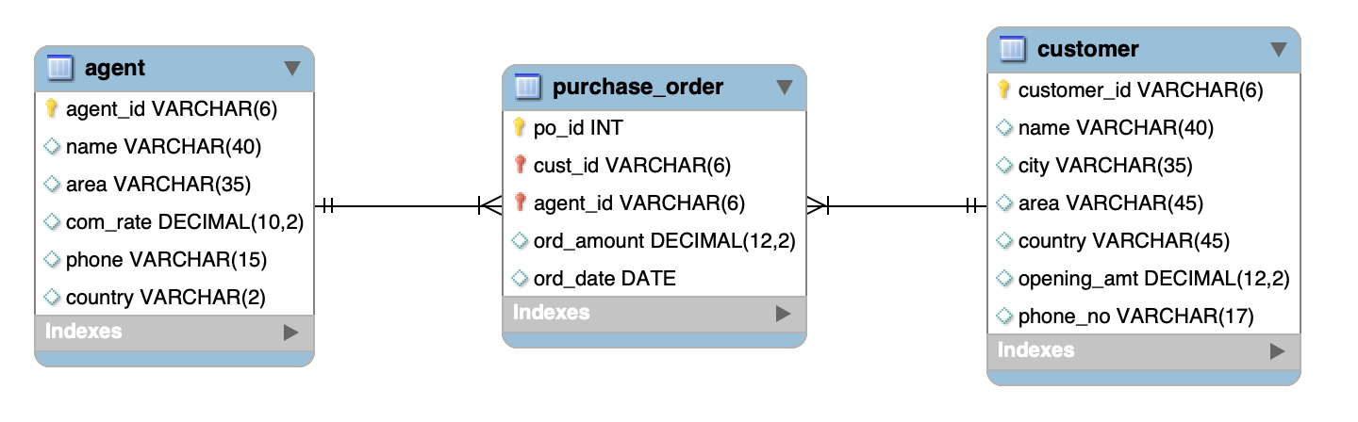

## Question 1

Create a list of all agents who service Sri Lanka (warning: look at the size of the country code to decide how you are going to search). Note that a telephone code will not identify the country.

## Question 2

Get a list containing customer_id, the name of the customer and the customer’s phone number for all customers whose area has been set to null.

## Question 3

Create a new purchase order for customer ‘AB2212’ using agent ‘CC112’. Create any order amount, use today’s date, and use the auto_increment feature for the po_id field.

## Question 4

One of the agents has a new phone number. The previous number was ‘1123-9000’ and their new number is ‘2000-2000’. Write the SQL query that performs this update.